Siddhanta Shiromani
Grahaganit adhyaya
Triprashnadhikar
(Section III, Chapter 1 : determination of three issues)

Verse No | Translations
1 | The scholars refer this as the “time system”, which contains detailed explanation of space and time’s [word mutilated beyond recognition]. Now I will describe this ambigous section.
2 | If we multiply the untravelled degrees of the Sign the sun is in (Sayana) by its own minute of the arc of rise and divide this product by 30 we will have the following Pranas. If we use instead of the untravelled degrees, the traveled degrees of the sun we will have the preceeding Pranas.
3-4 | If the required minute of the arc (that is, the number of Pranas from the sunrise to the time of whose Lagna/orient ecliptic point is to be determined) is greater than the untravelled degrees (as described previously), then first we subtract the following Pranas from the required minute of the arc and subsequently subtract the remainder from the rising Pranas of the subsequesnt Signs. (When no further subtraction is possible then the remainder is called Shesha/end and the rising minute of the arc of the sign which cannot be subtracted is called Ashuddha Rashi/uncorrected Sign.) If we divide the Shesha by the rising minute of the arc of the Ashuddha Rashi and multiply it by 30 we will have a result in degrees. Adding the degrees of the Ashuddha Rashi to this result and subtracting the degrees of the Sun from this sum we will have the Nirayana (Hindu Longitude) of Aries measured from the Hindu zero point of the ecliptic(Lagna). If the required minute of arc is lesser than the untravelled degrees then if we multiply the required minute of the arc by 30 and divide this product by its own minute of arc of rise we will have a result in degrees. If we add these degrees to the corrected position of the sun we will have the Hindu zero point of the ecliptic(Lagna).
5 | If the Sun-rise and the Lagna be on the different signs, then we will have to determine the following Pranas of the Sun and preceding Pranas of the Lagna as described above. Then we add these two and then add to these the rising Pranas of the intermediate Signs and if we know the Lagna then we can determine the required time. If the Sun-rise and the Lagna be on the same sign or more then we multiply the difference of the two by the rising minute of the arc and dividing this product by 30 we will have the required number of Pranas.
6 | If the Lagna be small than the sun then subtracting that from the a day we will have the required number of Pranas. As the civil day is determined by the position of the sun, hence the required time is determined without successive approximation.

Verse No | Translations
7 | It suffices to determine the sidereal time from Lagna and Lagna from the sidereal time from the sun.  If we need to determine the Lagna before Sunrise, then we should obtain the position of the sun and find its preceding Pranas; subtract them from the given time. From the remainder we subtract the rising times of as many Signs as is possible (Viloma), determine the Shesha and Ashuddha Rashi. We add these to the preceding degrees of the sun and also add to this the intermediate Signs and if we subtract this whole sum from the position of the Sun we will have the Lagna.
8 | The East-West line is roughly the joining of the extremities of the morning shadow as well as that in the afternoon of a cone placed at the centre of a circle drawn on a plane with any arbitray radius, when these shadows equal the radius of the circle. But this line is to be deflected keeping its western point (extremity) of the morning shadow fixed through a given distance at the eastern end perpendicular to it, where the above distance is measured in fingers.  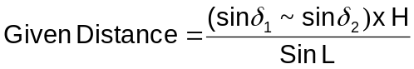  Where  sin δ₁ = Rsine of Declination of Sun at morning  sin δ₂ = Rsine of Declination of Sun at afternoon  H = Hypotenuse of Shadow  sin L = Rsine of Co-latitude
9 | If it is determined from the previously mentioned line (i.e. east-west line), we draw a fish structure by two arcs , which show the north south direction. If we place a rod (Kilaka) facing towards the polestar (Dhruva) then the north is towards the tip of the rod which points towards the polestar and the base of the rod is pointing south. From this however we can also determine East or West.  Determine the Bhuja (base of the right angled Triangle) and Koti (Cosine) from a shadow and place two rods, the first at the tip of the shadow equal in length of Bhuja, and the second at the base of the cone equal in length of Koti. The tips of these two rods make a right angle. Then the cosine-rod determines the east-west direction and the base-rod determines the north south direction.
10 | 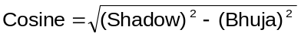The Bhuja defined as the distance of the extremity of the shadow from east-west line where the cone is placed at the intersection of the East-West line and North-South Line. We have Koti or cosine as :
11-12 | Adding the squares of Shadow and sine of altitude we have the square of hypotenuse. Hence we would be able to determine the shadow if we take the square root of the difference of square of hypotenuse and square of shadow. If H be the hypotenuse, C be the sine of altitude (Shanku) and S be the shadow, then we have :  S² = H² – C² = (H+C)x(H-C)  The words “Shanku”, “Nara” and “Na” mean the same thing, that is cone. The celestial parallax of the sun at noon is the latitude of the place, called Pala or Aksha. The altitud eof the sun then is called Lamba or co-latitude. Therefore Lamba + Aksha = 90°.

Verse No | Translations
13 | The right angled triangle formed by the cone, equinoctial shadow and the hypotenuse is the fundamental latitudinal triangle. Just as knowledge is the basis of money, fame and happiness, this triangle will be the basis of our future calculations. Also  (equinoctial Shadow)² + (Height of the Cone)² = (Hypotenuse)²
14 | The second latitudinal triangle is formed by the Sine of co-latitude (Perpendicular), Sine of latitude (base) and Radius (hypotenuse).  The third latitudinal triangle is formed by Kujyaa (Base), Apakramajyaa (Perpendicular) and Agraa (Hypotenuse).
15 | The fourth latitudinal triangle is formed by the Samamandala Shanku (Perpendicular), Agraa (Base) and Taddhriti (Hypotenuse). If we subtract the Kujyaa from Taddhriti we will have the fifth latitudinal triangle formed by the remainder as perpendicular, RSine of declination as base and Samamandala Shanku as hypotenuse.
16 | The sixth latitudinal triangle is formed by the first segment of RSine of amplitude, that is the difference of the line drawn from the base of the Unmandala Shanku and the East-West line is the perpendicular, the Unmandala Shanku as base, and RSine of Declination as hypotenuse.  The seventh latitudinal triangle is formed by the second segment of RSine of amplitude, that is the difference of the line drawn from the base of the Unmandala Shanku and the rising-setting line is the base, the Unmandala Shanku as perpendicular, and Kujyaa as the hypotenuse.
17 | The eighth latitudinal triangle is formed by the difference of the Samamandala Shanku and Unmandala Shanku as perpendicular, the difference of Taddhriti and Kujyaa as Hypotenuse and the first segment of Rsine of amplitude as base. These eight triangles are called fundamental latitudinal triangles.
18 | [As these triangles lie in the same plane as the circle of the latitude of a place, these are called latitudinal triangles. All the above triangles are right angled triangle. Of the remaining angles one signifies the latitude and hence the other signifies the co-latitude.]  The elements or the sides of all these latitudinal triangles are mutually derivable from similarity as they are related to each other in some proportion or other.  If the radius be multiplied by the perpendicular or bases and divided by the hypotenuses we will have the sine of co-latitude or sine of latitude.  [Note From Translator : Much of this verse is very badly mutilated. Although I have tried my best to guess the meaning and translate, it could be that it might be missing something.]
19 | The arc of Lambajyaa and Akshajyaa are respectively co-latitude and latitude. The sine of these are called {illegible} and Kotijyaa (cosine). If we multiply Akshajyaa (sine of latitude) by Kotijyaa (cosine) and divide that by Bhujajyaa we will have Lambajyaa (Sine of co-latitude). (Hence Akshajyaa can be computed from Lambajyaa).
20 | For any latitudinal triangle, if we multiply the RSine of declination by the hypotenuse and divide that individually by its perpendicular and base we have the first result as Agra and the second result as similar cone. If this similar cone be multiplied by the hypotenuse and divide that by the perpendicular we will have Taddhriti.

Verse No | Translations
21 | 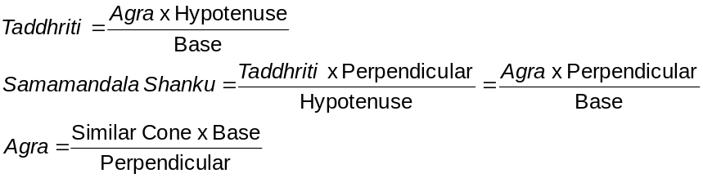
22 | 
23 | 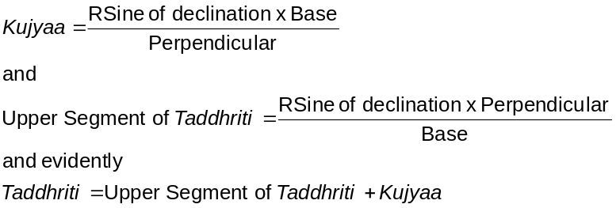
24 | 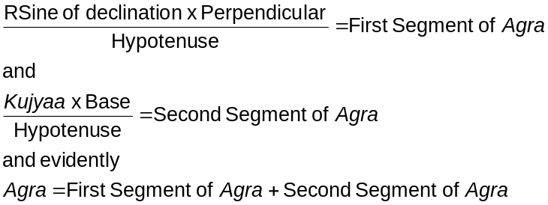
25
26 | 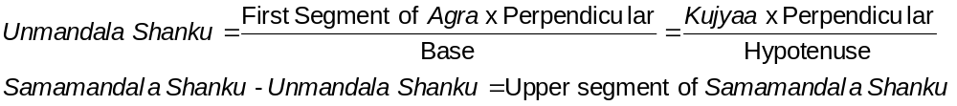
27 | 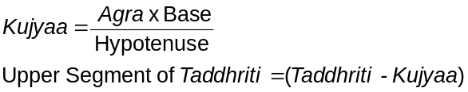  Having known these the others can be derived by multiplication/division and/or addition/subtraction.

[Note From Translator : Much of these verses (21-27) are very badly mutilated. Although I have tried my best to guess the meaning and translate, it could be that it might be missing something.]

Verse No | Translations
28 | 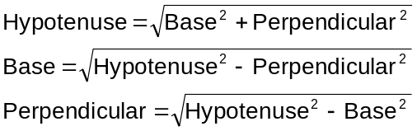  If two are known the third could be calculated easily for any latitudinal triangles.
29 | Note from translator : This verse is so mutilated that it is practically illegible. I am sorry I won’t be able to translate this.
30 | Here Kona Shanku is the cone formed at the moment of passing the vertical circle extending from N-E to S-W or N-W to S-E.  Now if we multiply this Kona Shanku by the equinoctial shadow of the place and divide the product by 12 we have will have a result (Shanku tala). If we add this result for Southern hemisphere and subtract this result for northern Hemisphere from the Agrajyaa we will get the Bhuja. Now taking this Bhuja as the Agra we will have to determine the second value of the Kona Shanku as described above. This way the Kona Shanku is determined without approximation.
31 | By ‘northern hemisphere’ (Uttara/Soumya) it is meant that the sun’s longitude is in northern hemisphere, that is, from 0° to 180° (or six Rashis starting from Aries). Similarly, by ‘southern hemisphere’ (Dakshin/Yamya) it is meant that the sun’s longitude is in southern hemisphere, that is from 180° to 360° (or six Rashis starting from Libra). Because of circular shape, depending on the sun’s longitude the direction is fixed according to the above mentioned convention. Accordingly the latitude and co-latitude are always deemed as south and north respectively.  Bimala Prasada Siddhanta Saraswati’s Note :  The Europeans denote the latitude to the north of equator by a ‘+’ sign and writing ‘N’ to denote north. If the sun’s is to the north of equator then its Declination is denoted as North and written with a ‘+’ sign.
32 | If the latitude and co-latitude being ‘added to the declination, subtracted from the declination or being decreased by the declination’ as the case may be, we have the zenith distance and the altitude of the celestial body at noon. The zenith distance and altitude are mutually complementary. That is, zenith distance + altitude = 90°.  Note from translator : It took me quite a pain to decipher the main verse. But there is a note to this verse. A considerable part of this note is darkened so much that it is practically illegible. I am sorry I won’t be able to translate this note.

Verse No | Translations
33-34 | Here at noon the Drigjyaa (zenith distance) is the Sine of hour angle and Dinardha Shanku (altitude at noon) is the sine of altitude.  The product of radius and the Unmandala Shanku be divided by the Sine of Chara is called Yashthi. The Yashthi increased or decreased by the Unmandala Shanku gives altitude at noon, according as the Sun is in the northern or southern hemispheres.  The sum or difference of Dujyaa (day-radius) and Kujyaa is called Hriti, according as we take them in northern and southern hemispheres. Similarly the sum (in northern hemisphere) or the difference (in the southern hemisphere) of Charajyaa and radius is called Antyaa.  Symbolically,  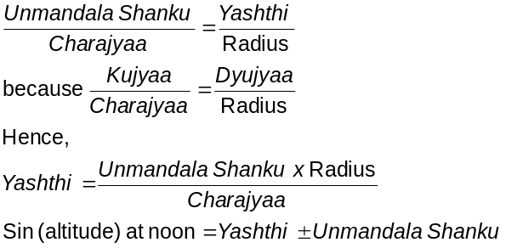
35 | 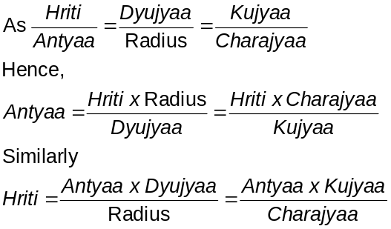
36 | 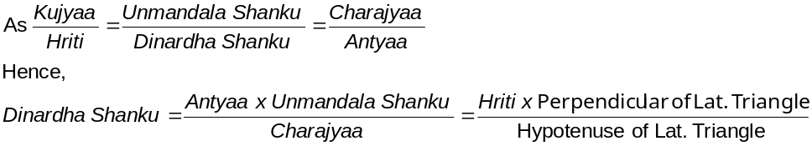
37 | The sign is positive or negative according as the sun is in northern (+ve) or southern (-ve) hemispheres. If the fraction is negligible in the northern hemisphere then it may be subtracted from the Agra to yield the Uttara Drigjyaa.

Verse No | Translations
38 | The meridian zenith distance of the sun can also be calculated from the following formula :
39 | Another alternate method of calculating the meridian zenith distance :  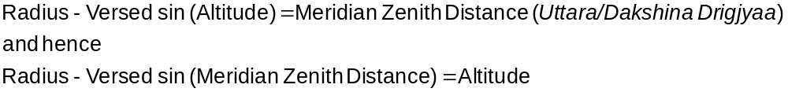  Hence we can calculate the meridian zenith distance from Shanku (Sine of altitude) and the reverse of the Sama/unmandala Shanku. All these described above is in half day terms.
40 | 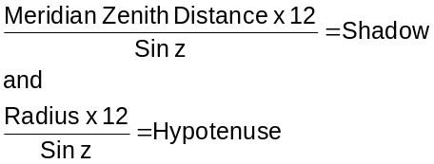  Where sin z = Shanku (sine of altitude)  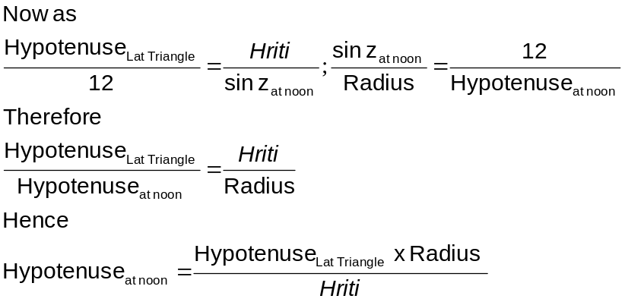
41 | If we divide 101530 by the sine of sun’s longitude we have a result called a Para. Hence we can get the Hypotenuse of the shadow for sun in the Unmandala Shanku as the following formula describes :  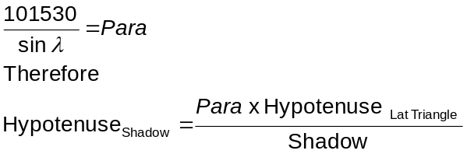  Where sin λ = sine of sun’s longitude

Verse No | Translations
42 | 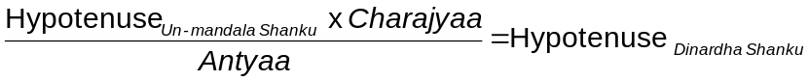  Where Dinardha Shanku = Length of the perpendicular let fall on the plane of horizon from the point representing the position of the celestial body in the armillary sphere when that body is on the celestial meridian.
43 | Another method of finding out the Hypotenuse _{Dinardha Shanku} is as follows :
44 | The ancient scholars have found out the conic shadows when the sun is on the meridian, prime vertical and the Kona-Vritta (that is the vertical, when the northern and southern azimuths fixed by the Hindus are 45°) by different methods. I would consider the person the very master of astronomers, if any body could give a method to find the shadow in any required direction which holds goods in all cases universally.
45 | The angle between any vertical and prime vertical measured on the horizon is defined as Digangsha. The sine of Digangsha is called the Drigjyaa (azimuth), measured wither on the Eastern or Western Hemisphere.
46-48 | First assume the equinoctial shadow to be :    Where sin a = Drigjyaa (sine of azimuth)  Use this to find out the sine of the corresponding latitude (sin L). Multiply this sin L with the sine of declination (sin δ) and divide this product by the sine of the latitude of the place (sin φ) to give us the sine of declination (sin D) where this declination is hypothetical one. Now using the corresponding latitude L and this hypothetical declination D, we have to find out the meridian zenith distance (Z) using the formula Z + D = φ . Using this meridian Zenith Distance determine the shadow as described in the verse 32, which would be the shadow in the required direction.  In computing the shadow in a given direction, there may be two shadows at times in the northern hemisphere. When sin a < Agra , there would be no shadows in the southern hemisphere. Now in computing the second shadow e have to take 180°-L as the latitude where L is the computed latitude, and we have to proceed in the same way as we have done before.

Verse No | Translations
49-51 | Let [(Radius x Equinoctial Shadow)² + (12 x sin a)²] be defined as Prathama. And let (Radius x shadow x Agra) be defined as Anya. Now we divide both Prathama and Anya by (sin²a – Agra²). They are still called Prathama and Anya. Then we have :  According as the sun is in northern hemisphere (then subtract) or southern hemisphere (then add) the square root part.  When sin a < Agra in the northern hemisphere, the above formula changes to :  According as the sun is in northern hemisphere (then the square root part is +ve) or southern hemisphere (then the square root part is -ve).
52 | Determine base from Karnagraa. And we have,  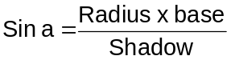  Where sin a = Drigjyaa
53 | In the previous two verses the magnitude of the shadow was obtained in a given direction; now we shall obtain the same when the time is given. Here ‘Unnata’ is defined as the time that has elapsed after sun-rise or that which is the balance of the day time. The unnata subtracted from half day (Dinardha) gives us the Nata.
54 | The Unnata time decreased or increased by the Chara according as the sun’s declination is north or south is called Sutraa. Now Kalaa is defined by the following relation :  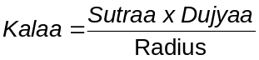
55-57 | There is another method of computing the Kalaa as given below :  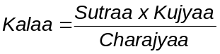  And for any latitudinal triangle :  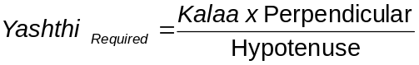  Or alternatively if we multiply the Unmandala Shanku by Sutraa and divide this product by Charajyaa we will also have the required Yashti (Ishtha Yashthi). The Sutraa increased or decreased by the Charajyaa according as the Sun is in the northern or Southern hemisphere, we will have what is called the required Antyaa (Ishtha Antyaa). Similarly Kalaa increased or decreased by the Kujyaa is what is known as required Hriti (Ishtha Hriti). Similarly required Yashthi (Ishtha Yashthi) increased or decreased by the Unmandala Shanku gives us the required sine of altitude (Ishtha Shanku).

Verse No | Translations
58-60 | In the required time, the versed sine of the hour angle (Nata) is called Shara. If Shara is being subtracted from Antyaa we have the result as required Antyaa (Ishta Antyaa). Now the required Hriti (Ishta Hriti) is calculated as below :  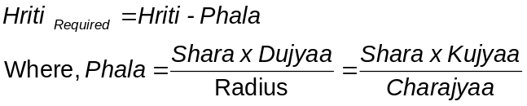  We would have a new item called Urdhwa, which is defined by the following operation :  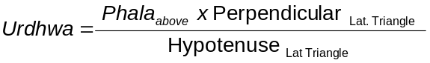  Alternnatively, the above Urdhwa can also be derived if we do the following operation on the above mentioned Phala,    If we subtract this Urdhwa from the Dinardha Shanku then the result is required sine of altitude (Ishta Shanku). Hence Ishta Shanku is derived from the hour angle (Nata).
61 | Note from translator : A considerable part of this verse is darkened so much that it is practically illegible. I am sorry I won’t be able to translate this verse.
62 | The Hypotenuse of the shadow, when the sun is on the unmandala be multiplied by Kujyaa. Else when the sun is on the prime vertical be multiplied by the Taddhriti. Or again when the sun is on the meridian mulyipled by the Hriti, all these divided by Ishta Hriti would be equal to the required Hypotenuse (Ishta Karna).
63 | If in any context the quantity to be subtracted, exceeds the quantity from which it is to be subtracted, it goes without saying theta the subtraction should effected reversely and in the place of addition subsequently prescribed subtraction should be done and vice-versa.
64 | If the hour angle be more than 50 Ghatikas then we will have :  Hence, the unmandala Shanku is not observable in the south as it is below the horizon. However we can compute that for effecting the proportion.
65 | The Sun crosses the prime vertical when his northern declination falls short of latitude. Then alone there is sense in giving the magnitude of his shadow at the moment. When the sun does not cross the prime vertical at all, the Samamandala Shanku which could be computed out of its formulation, though non-existent, under the sun, yet, it could be used in proportions and as being said in verse 62 no blunder is committed.

Verse No | Translations
66-68 | Another measure for Required Antyaa (Ishta Antyaa) is  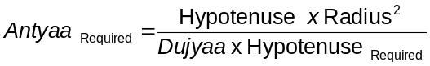  Now,  And  Distance from the horizon in Time (Unnatakaala) = Half the day (Dinardha) – Hour Angle in Pranas  If (Antyaa – Antyaa_{Required}) < Radius, then subtract radius from the given difference. Let  (Antyaa – Antyaa_{Required}) –Radius = ψ, using this we have,  the hour angle in Pranas = 5400 + sin⁻¹ (ψ).  [Note From Translator : Much of this verse is very badly mutilated. Although I have tried my best to guess the meaning and translate, it could be that it might be missing something.]
69 | We subtract Charajyaa from or add it to the Ishta Antyaa according as the declination is north or south. We then obtain the inverse of sine of the remainder, and add this to Chara or subtract it from Chara according as it is in northern or southern hemisphere. If we convert this result in time we get the Distance from the horizon in Time (Unnatakaala).
70-71 | We multiply the conic shadow at noon with the radius and divide it by the hypotenuse of the shadow which when converted to arc yields the hour-angle in degrees. If the extremity of the shadow be on the north then the hour-angle is to the south and if the extremity of the shadow be to the south then the hour-angle is to the north. This hour angle is being decreased or increased by the latitude gives Sun’s declination (in degrees) according as the extremity of the shadow is to the north or south. The method of determining the sun’s longitude from its declination is being discussed in detail in the Gola-adhyaya section of this book. If the hour angle and the declination are of the same direction, then their difference, otherwise their sum will be the latitude.

Verse No | Translations
72-73 |  [Translator’s Note : No explanation about  Karna Vrittagra is obtained from any  source ]  This Karna Vrittagra is to be taken as belonging to the opposite hemisphere to the Sun. The shadow is always to the north. According declination of the sun is north or south we have,  If the extremity of the shadow be to the north and the declination is to the north then  Else, if the declination is south, then we have  And if base be north then we will have  Else if base be to the south then  And additionally  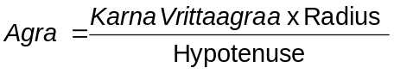  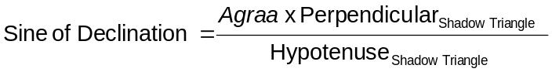
74 | Seeing the shadow of the cone, the azimuth and the longitude of the sun or seeing two shadows with their respective directions, who ever knows the Equinoctial Shadow of the place I consider him the Eagle (literally Garuda) who can overcome the false pride of puffed up snakes (refereeing to astronomers).
75 | Given that Hypotenuse _{Shadow} = 30 fingers, base = 3 fingers, and when Hypotenuse _{Shadow} = 15 fingers north, base = 1 finger compute the latitude, or again given sine of declination = 846 and the Hypotenuse and base of the shadow is known, compute the equinoctial shadow.
76 | Answer to the first question asked previously :  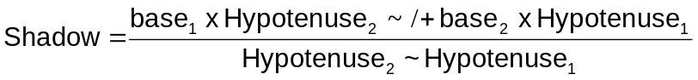  According as the bases are in the same or opposite direction.

Verse No | Translations
77-78 | The answer to the second question asked previously :  Let Laghu (l) be defined as :  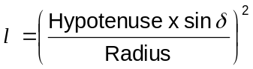  Where sin δ = sine of declination  Again let Adya (a) be defined as :  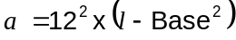  Again let Anya/Para (p) be defined as :  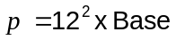  Now let us divide both Adya and Para by (l ~ 12²) and call them still Adya and Para, then we will have  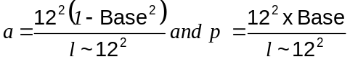  Then the shadow is given by,  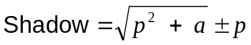  According as the base is to the north or south.
79 | When the sun’s longitude is 135°, the shadow of the cone is 12 fingers and west, then compute the latitude.
80 | Answer to the question asked previously :  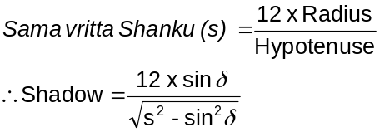  Where sin δ = sine of declination
81 | O my friend, an observer at Ujjain observed that the sun was on the prime vertical 5 Ghatikas after sun-rise or 5 Ghatikas after noon. If you could give the declination of the sun at that declination of the sun at that moment I would consider you as a person who has profound mathematical knowledge and has the guts to ride on wild elephants.
82-83 | Assume the sine of the distance from the horizon in Time (Unnatakaalajyaa) be the required Hriti (Isnta Hriti) in the first place. Multiply this by 12 times shadow, and divide the product by the square of the hypotenuse of the shadow. This result gives us the approximate value of the sine of declination (sin δ). Using this approx sin δ determine the Dujyaa, Kujyaa, Charajyaa, {illegible} and Chara. Use the Chara to find out the corrected value of required Hriti (Isnta Hriti). Multiply this by sin δ determined previously and divide the product by the assumed required Hriti (Isnta Hriti) to give us the nearer approximation of sine of declination (sin δ). Repeat this process till a stationary value has been reached. That would be the corrected value of sine of declination (sin δ).

Verse No | Translations
84-85 | Obtain  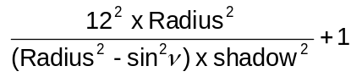  Where sin ν = Sine of Nata in time units  Divide this result by square of the radius and take the square-root of it to give us the sine of declination, that is  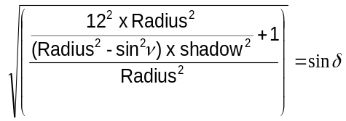  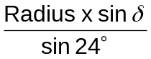  Then the arc of the expression gives us the longitude of the sun.
86 | When the sun is on the prime vertical the conic shadow is noted to be 16 fingers. The distance from the horizon in time (Unnatakaala) be 8 naris. If you can give the sine of declination (sin δ) and the shadow of that place, I shall consider you nothing short of a person who is an adept in solving the totality of the diurnal problems.
87-88 | As described before, assume the sine of the distance from the horizon in Time (Unnatakaalajyaa) be the required Hriti (Isnta Hriti) in the first place. Multiply this by 12 and divide the product by Samavritta Shanku, we will have the result as the approximate Hypotenuse of shadow. From this find our the shadow. If this shadow be multiplied by the Samavritta Shanku and divided by the hypotenuse of the shadow we will have the approximate declination. Using this approx sin δ determine the Dujyaa, Kujyaa, Charajyaa, etc and Chara. Use the Chara to find out the corrected value of required Hriti (Isnta Hriti). Use this to determine the hypotenuse and nearer approximation of sine of declination (sin δ). Repeat this process till a stationary value has been reached.
89 | O mathematician ! at a place where the shadow is 5 fingers, and there 10 naris after sun-rise we observe the required altitude to be 9 fingers. Tell me what the longitude of the sun would be, if you are an adept in computing as well as understanding the geometry of the sphere.
90-91 | As described in verse 80, we have a relation involving shadow, radius, hypotenuse of the shadow and Mahashanku. Here the required shadow is 9 fingers, the true shadow is 15 fingers. Using this we can determine the Rsine of altitude (Mahashanku) to be 2750.24. Now assume sine of the distance from the horizon in Time (Unnatakaalajyaa) as the Ishta Antyaa. The we will have,  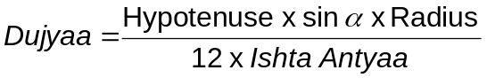  Where sin α = sine of altitude (Mahashanku)  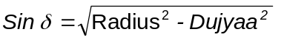Also  Where sin δ = sine of declination  Now use this sin δ to find out the Chara and then determine the Ishtaantyaa as described in verse no {illegible} . Repeat this process until you have obtained neared approximations of Dujyaa and sin δ. From the corrected sin δ, determine the corrected sun’s longitude by putting the values in the previously given formula.

Verse No | Translations
92 | O mathematician ! Please tell me the magnitudes of equinoctial shadow and the longitude of the sun if at a place on a particular day Kujyaa is 245 and Taddhriti is 3125.
93 | Answer to the above question  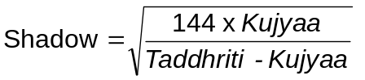  And  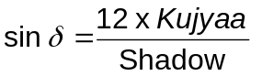  From this value of sin δ, determine the corrected sun’s longitude by putting the values in the previously given formula.
94 | Given that sin δ + Sama Shanku + Taddhriti – Kujyaa = 6720 and Kujyaa + Agraa + sin δ = 1960 [Where sin δ = sine of declination]. Then I shall consider him who finds the shadow and the longitude of the sun as the very sun illuminating the lotuses of astronomers.
95 | Answer to the above question :  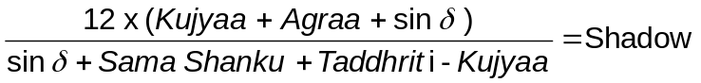First obtain  From this shadow compute the hypotenuse of the shadow. Then from it obtain  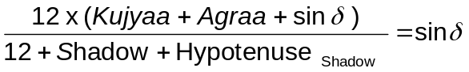  Where sin δ = sine of declination  From this sin δ find out the longitude of the sun.
96 | Given that sin δ + Sama Shanku + Taddhriti – Kujyaa = 1440 and Taddhriti + Agraa + Sama Shanku = 800 [Where sin δ = sine of declination]. Whoever finds the magnitude of the shadow and the longitude of sun, I shall deem him as the very sun illuminating the lotuses of astronomers.
97 | Answer to the above question :  First obtain  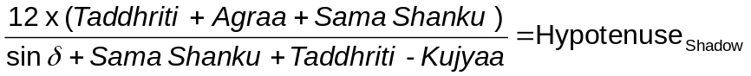  From this hypotenuse of the shadow compute the shadow. Then from it obtain  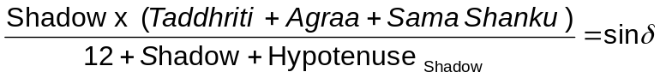  Where sin δ = sine of declination  From this sin δ find out the longitude of the sun.

Verse No | Translations
98 | If at a place the shadow be 9 fingers and the Chara be 3 naris, if you could compute the longitude of the sun, then certainly you are a leader amongst the astronomers, O Scholar !
99 | Answer to the above question :  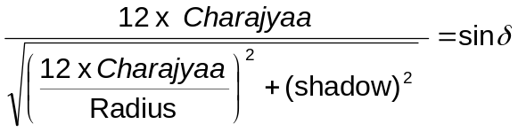  Where sin δ = sine of declination  From this sin δ find out the longitude of the sun.
100 | If Dujyaa + sin δ + sin λ = 5000 [Where sin δ = sine of declination and sin λ = sine of longitude of the sun]. And if you have studied Madhyamaaharana (computing the mean position), the please compute the mean longitude of the sun.
101 | Let  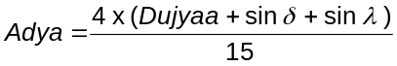  Then using this we will have  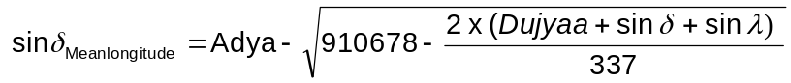  From this sin δ find out the longitude of the sun.
102 | In a place where the shadow is 5 fingers, and  sin δ + Sama Shanku + Taddhriti + Kujyaa + Agraa = 9500.  O mathematician ! if your are so skilful in understanding the spheres and dealing with altitudinal triangles find them individually (i.e. sin δ, Sama Shanku,Taddhriti,Kujyaa and Agraa).
103 | Note from translator : This verse is so mutilated that it is practically illegible. I am sorry I won’t be able to translate this.
104 | If the sum of Agraa, sin δ, and Kujyaa be 2000, find them individually o mathematician if you be an adept in geometry of the sphere and computation.
105-107 | On the horizontal plane mark a point and through it draw the East-West line and also draw the north-south line. If the planet is in the east, mark the Perpendicular of the shadow to the west and if the planet be on the western hemisphere mark this perpendicular towards the east. From the extremity of the perpendicular, mark the Base taking in consideration north-south direction. Draw the shadow from the point (extending a rod) so as to form a right angled triangle with base and perpendicular. Extend a thread from the point of intersection of the base and shadow to meet the cone’s top so as to form hypotenuse of the right angled triangle of which the other side are the cone and the shadow. Through this thread place a Nalaka (a simple tube) such that the lower extremity of the Nalaka coincides with the eye. Seeing through the Nalaka, the planet is to be seen. I shall tell how the planet could be seen in water as well.

Verse No | Translations
108 | Place the cone at the point of intersection of the base and shadow and holding the Nalaka along the join of the top of the cone and the point, the planet could be seen in a basin of water placed at the point.
109 | See the planet in the sky or on water as is being described. This method is being described for the King who has an eye of appreciation for the same.
Hence ends the chapter named Triprashnadhikar
of Grahaganita part of Siddhanta Shiromani

That is, if the sun be in the r^{th} degree then the un-traveled degrees are (30-r)°.
That is difference more than 30°.
RSine of the part of the arc of the diurnal circle intercepted between the rising setting line and 6 o’ clock circle.
RSine of declination
Measure of amplitude, that is, the arc of celestial horizon lying between east point and the point of rising of the concerned heavenly body.
RSine of altitude of the celestial body (sun) when upon the prime vertical i.e. length of the perpendicular, let fall on the plane of horizon from the point representing trhe position of the celestial body in the armillary sphere when it is on the prime vertical.
Bimala Prasada Siddhnata Saraswati has not explained what is meant by Taddhriti. But I found this definition in D. Arkasomyaji’s book on Siddhnata Shiromani, Taddhriti = Hriti of a celestial body when it is on the prime vertical.
Length of Perpendicular let fall on the plane of the horiozon from the point representing the position of the celestial body (sun) in the armillary sphere when the body is on the equatorial horizon; i.e. RSine of the altitude when the sun crosses the unmandala.
Arc of the celestial equator lying between the 6 o’ clock circle and the hour circle of a heavenly body at rising; half of the variation of a sideral day from 30 Ghatika.
RSine of the arc of the diurnal circle between the celestial meridian and the point where the heavenly body concerned rises; length of the perpendicular from the point of intersection of the diurnal circle with the meridian on the rising setting line.
Day measure; versed sign of half the day.
Bimala Prasada Siddhnata Saraswati has not explained what is meant by Karnagraa. But I found this definition in D. Arkasomyaji’s book on Siddhnata Shiromani, 

